

**ITE120 Final Project Report**

**Project Title: Stamford Hospital HTML website development**

**Course: ITE120 - Web Development I**

**Section 1**

**Term 1-2021**

**Course Teacher: Atikom Srivallop**

**Group Members:**

**Kongpob Wisitsakwasin 2011090005**

**Tinnapob Jiamjriyawat 1901070011**

**Phachathakorn Prathumma 2010070003**

**Fardina Kabir 1910080005**

Table of Contents

Introduction 3

Header & Logo 4

Menu Bar 5

Home 9

Doctor 12

Appointment 16

Menu Option 25

Contact 26

About 27

Article 30

Footer 37

Conclusion 41

# Introduction

Stamford Hospital website was created and designed for a hospital or healthcare facility. We needed to make sure that our website is user-friendly because these websites are so often used by people in distress; therefore, users must be able to accomplish tasks easily, such as on the homepage, be able to find promotions and packages on absolute surgery, checking COVID-19, and child health check.

The menu bar is created for users to navigate through the home page as an option, then the menu option on the menu bar that includes an article page, another page about the hospital, and a contact page as well. The menu bar also includes another option named “Doctor” which is used to provide information about the doctors working at the Stamford Hospital. The last option on the menu bar is the page for users to make appointments with the doctors.

We used notepad as a tool to write the HTML, CSS, and JavaScript code for the development of the web pages and web browsers to view these pages by adding extensions to the text file with .html in place of .txt. In the About Us section of the footer, there is a brief description of the Stamford Hospital, as well as links to all of the website's pages in the Pages section, so that when users reach the bottom of the page, near the footer, they can easily click to any of the links to the pages they want to visit next without having to return to the top of the website.

There's a section called Contact Us that tells visitors how to get in touch with the hospital in an emergency or to ask any important questions concerning the hospital's services. Overall, the website includes pages that users commonly need for looking at. We will be providing more insights and details about the contents created for every page with codes and screenshots of the website. We attempted to make the website aesthetically pleasing, as well as responsive, authoritative, user-friendly, and informational.

# Header & Logo

The website header includes the website title "Stamford Hospital" as well as a logo image entitled "Photo/Favicon.png" as an icon that can be viewed clearly in the tab whenever we browse any page of the website. We developed code for the title to show with the symbol on all of the pages. We also referred to and linked to the style.css file for each page, which is used to specify styles for every web page, including the design, layout, and display variations for the many pages we made for the website.

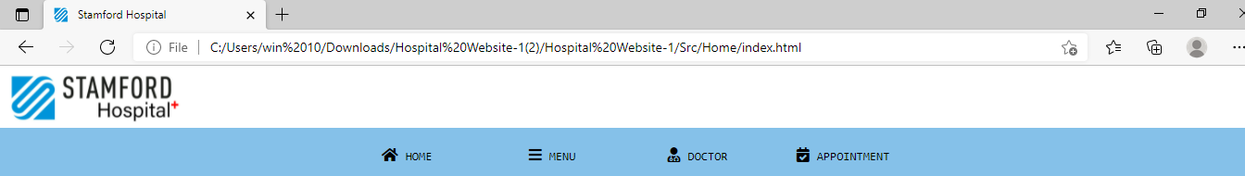

Figure 1: Header and logo of the website

In the header code, the code that we used for referring to style.css file is: <link rel="stylesheet" href="style.css">. The code that allows us to use the icon: <script src="[https://kit.fontawesome.com/fe2c9b11c2.js"crossorigin="anonymous](https://kit.fontawesome.com/fe2c9b11c2.js%22crossorigin=%22anonymous)"></script>. Finally, <link rel="icon" href="Photo/Favicon.png"> code is used make use of picture "Photo/Favicon.png" as an icon.

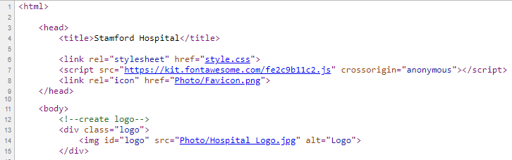

Figure 2: HTML code relevant to header and logo

The logo of the website is designed using online graphic tools and was saved as “Photo/Favicon.png”. Using its name and location, we were able to make it transparent on all the website pages by creating a div class for the logo i.e., <div class="logo"> and using the code for the logo div class as shown from.

Figure 1:

<div class="logo">

<img id="logo" src="Photo/Hospital Logo.jpg" alt="Logo">

</div>

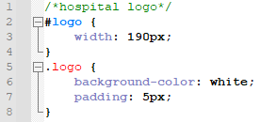

Figure 3: CSS code for the logo has width, padding, and background color set

Overall, the HTML document head section defines the page title, links to files on which the HTML page depends, and the logo icon. The website inserts the picture logo as the icon in the title bar. The icon logo is sometimes referred to as the favicon. Including favicons is also considered to improve a website's SEO. The logo appears on all of the website's pages by utilizing the div class "logo." In HTML, the head element is used to specify the document's head section. As a result, the HTML components within the head element convey critical information such as the site's name, the associated style sheet, and the iconic logo.

# Menu Bar

The menu bar is intended to direct visitors to the home page as an option, followed by the menu selection on the menu bar, which includes an article page, another page about the hospital, and a contact page. The navigation bar also has a "Doctor" option, which gives information on the Stamford Hospital's physicians. The last item on the navigation bar is a website where individuals may schedule appointments with doctors. Figure 3 shows a simple horizontal navigation bar with a blue background color that changes the background color of the links as the user drags the mouse over them.



Figure 3: Menu Bar

Figure 4 shows the HTML code for the navigation bar within the HTML document's body section. To begin, we wrote the HTML code in any text editor or opened the current HTML file in the text editor where we wish to create the Navigation Bar. Now we must define the <div class="menu-bar"> in the body element where we want the bar to appear.

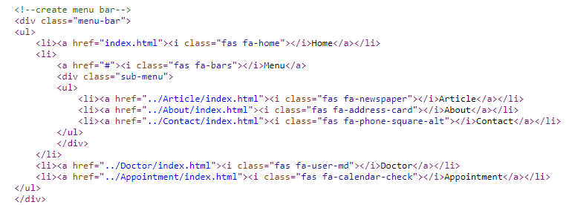

Figure 4: HTML Menu Bar code

Then we must define the ul tag, which is used to display the unordered list. The list elements must then be defined in the li tag. We must define the things that will appear in the navigation bar.

To specify the style for all HTML pages, an external style sheet is needed. The CSS code for the menu bar is contained in the external style sheet. To utilize an external style sheet, provide the following URL in the head section of each HTML page:



Figure 5: The Html code for importing the CSS codes in the Html document

Any text editor may be used to create the external style sheet. The file must be saved with a .CSS extension and must not contain any HTML code. We now defined several id properties that are utilized to set the location and color of the navigation bar. We may also modify the value of properties to meet our needs. We set the up-menu’s width and margins as well.

In this article, we will explain we will demonstrate how we applied several widely used CSS attributes. The CSS color attribute specifies the text color. The font-family CSS attribute specifies the typeface to be used. The font-size CSS attribute specifies the text size to be utilized. A border around an HTML element is defined using the CSS border attribute. The padding (space) between the text and the border is defined by the CSS padding property.

To remove the underline, add text-decoration: none; To modify the CSS vertical navigation bar, add various properties. The hover selection specifies that the background color changes when the mouse pointer moves over a link in the CSS navbar. The position: sticky; attribute is used to place an element dependent on the user's scroll position. When the scroll reaches a specific point, this CSS attribute causes the items to stick. A sticky element toggles between fixed and relative attributes based on the scroll position.

Figure 6 shows how to remove the browser default navbar settings from.menu-bar ul, such as "list-style-type: none," which eliminates the bullets from CSS navigation bars, and "margin: 0; and padding: 0;" which removes the browser default spacing settings.

By giving the display: inline attribute to a list of links, CSS generates horizontal navigation bars. This CSS file adds:hover to the horizontal navigation bar, which changes the background color when the pointer enters it. Then, right before the opening nav tag, we must type the header tag. We also need to close this tag. Finally, we must save the Html file and then execute it in the browser. Figure 3 depicts the result of the aforementioned HTML code.

Here is what the "styles.css" file, which consists of the CSS code for the menu bar, looks like in figure 6:

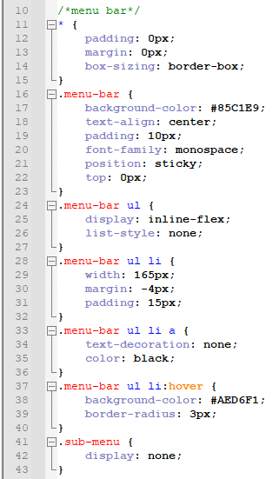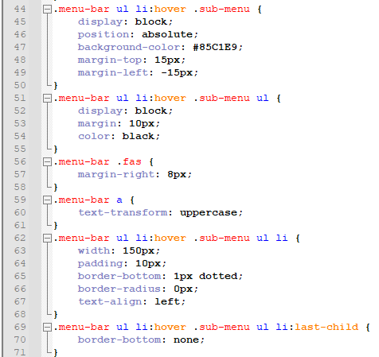

Figure 6: Overall CSS code for the menu bar

# Home

On the home page, patients can be able to find promotions and packages on absolute surgery, checking COVID-19, and child health check. The website showcases different icons representing various sections of the hospital, and they are Heart, Cancer, Bone, Brain, Ambulance, Digestive, Health, Surgery, and Respiration. The following figure portrays the screen capture of the first sets of sections of the homepage with a background picture followed by the website icons.

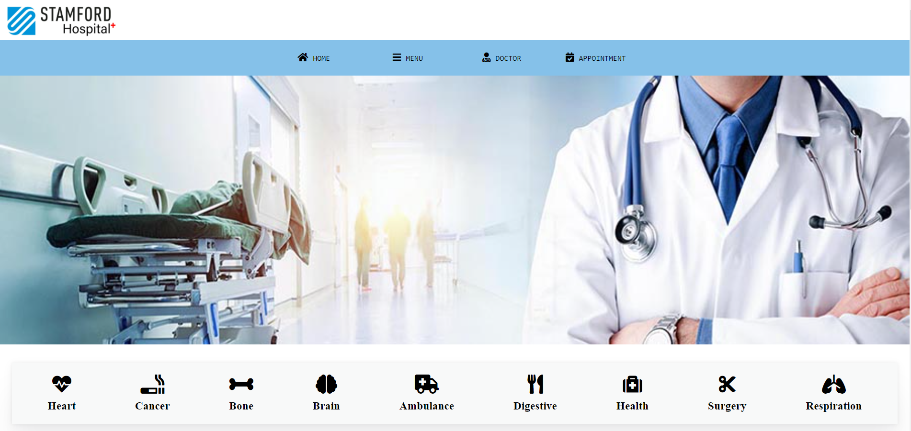

Figure 7: Back-ground image followed by sections with icons representing services available at the hospital

The code <div id="home-photo"></div> has only been used in HTML, which is used to set the photo as shown in figure 7 to full width, with a certain height, i.e., following the menu bar. Figure 8 has been used to show the CSS code that is used to set the height, background-image, and background-size within the div id named “home-photo".

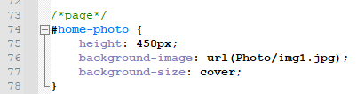

Figure 8: CSS code for div id "home-photo"

The HTML code <div class="service"> has been used to create a section primarily for presenting the icons horizontally. The CSS code for the div class named service has been shown in figure 9.

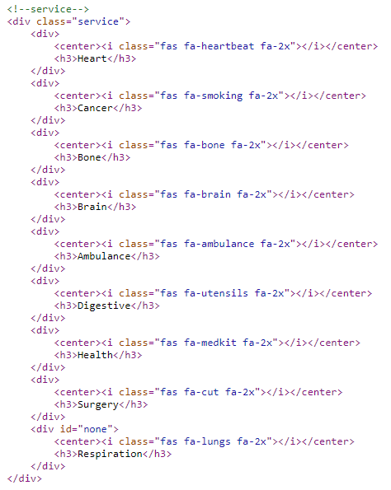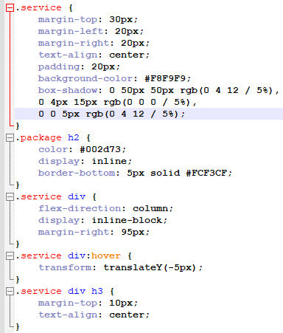

Figure 9: HTML (left of the figure) and CSS (on the right) code for <div class="service">

Another section for promotions and packages on absolute surgery, checking COVID-19, and child health check as shown from figure 10.

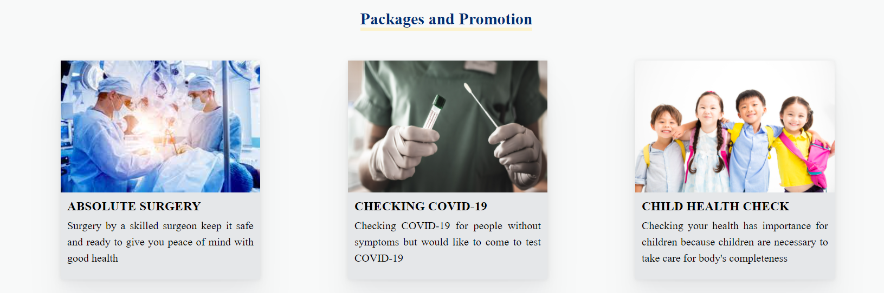

Figure 10: Screen capture of packages and promotions on homepage

Figure 11 has been used to provide the CSS code for <div class="package"> which is mainly for promotions and packages.

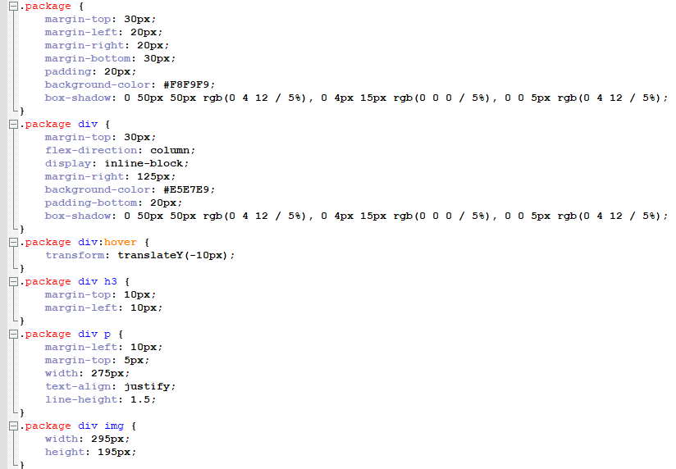

Figure 11: CSS code for packages and promotions on the homepage

Figure 12 has been used to show the HTML code created in response to the div class package.

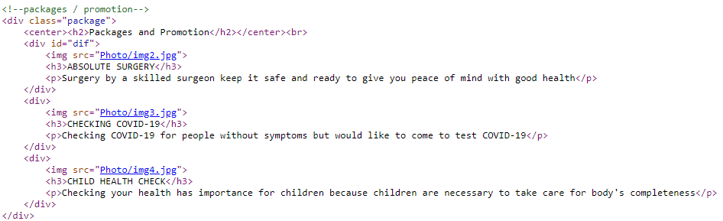

Figure 12: HTML code for packages and promotions on the homepage

Following that, HTML and CSS were used to develop sections on the homepage for promotions and packages, absolute surgery, checking COVID-19, and child health check, as well as to display various icons representing various hospital sections, including Heart, Cancer, Bone, Brain, Ambulance, Digestive, Health, Surgery, and Respiration.

# Doctor

The doctor’s page consists of the search engine and information and profile for all doctors working at the Stamford Hospital. JavaScript has been used besides HTML code in the HTML page of doctors to implement the function of the search engine. The search engine recommends the profile of doctors whenever a closely matched input of characters such as texts has been typed.

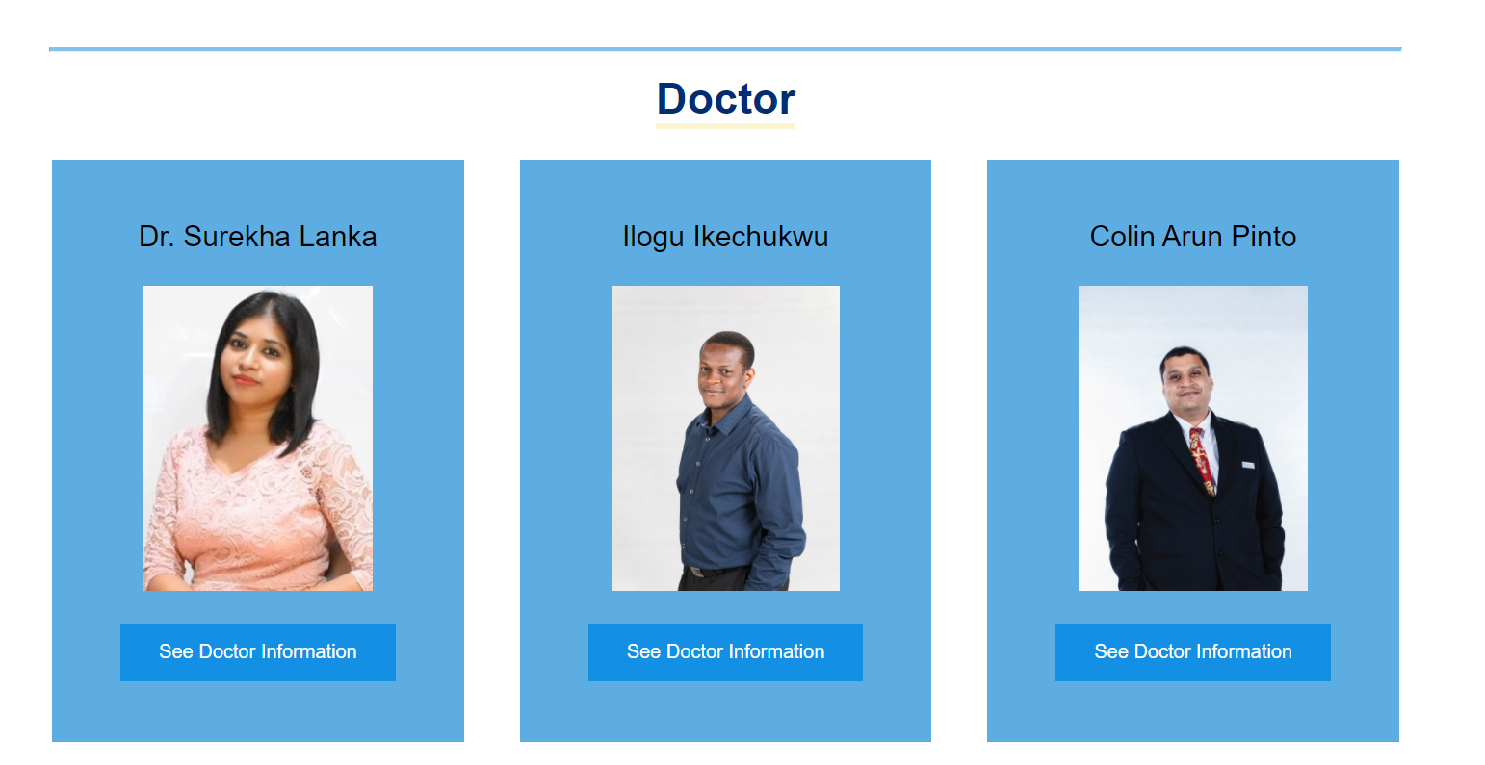

Figure 13: The doctor’s page views the profile of the doctors along with links to see more information about them

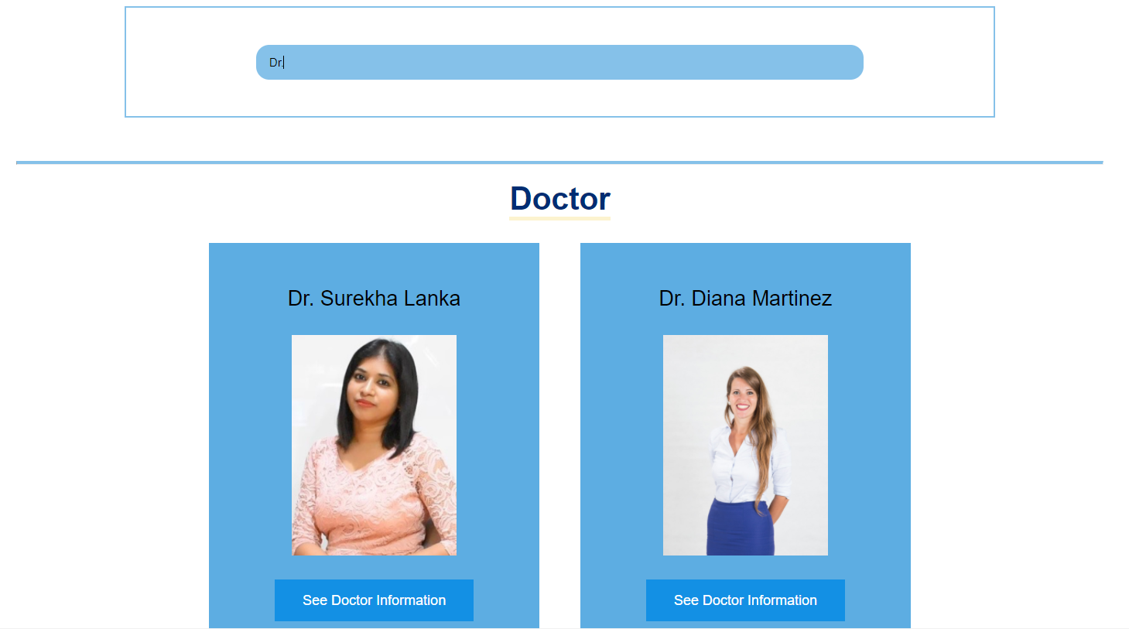

Figure 14: When a closely matched input of characters, such as text, is inputted, the search engine offers the profile of a doctor

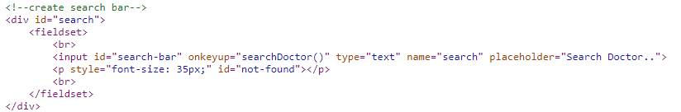Figure 15: The HTML code along with JS code in <div id="search"> for search engine implementation

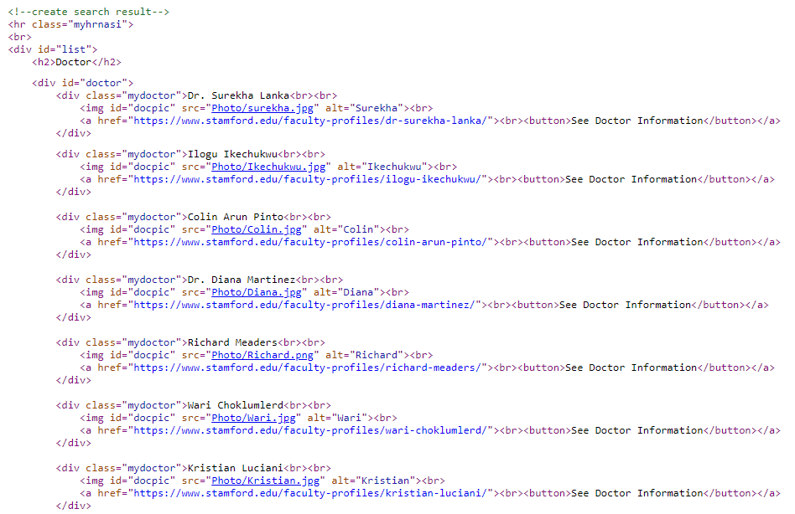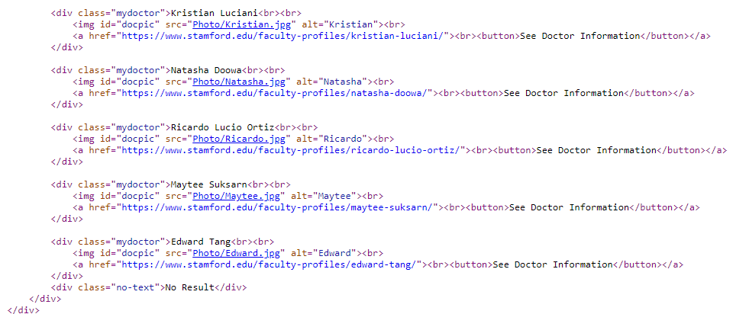

Figure 16: The HTML code created for search results and profile of every doctor with links to more info about them

The next figures 17 and 18 illustrate the JavaScript code and CSS code used for the search engine optimization; it also represents CSS code for the profile info for the doctors.

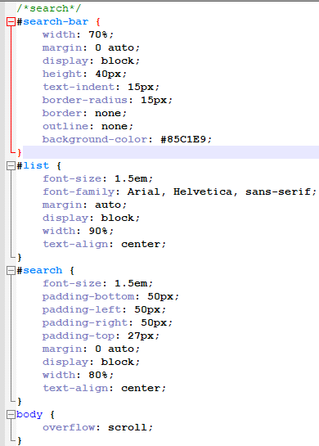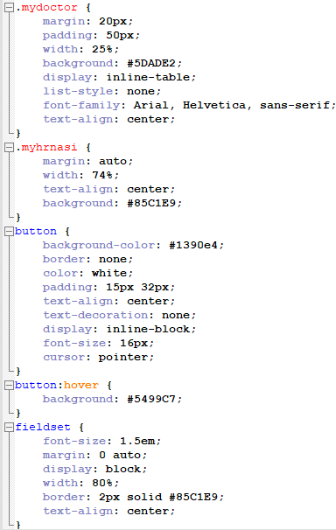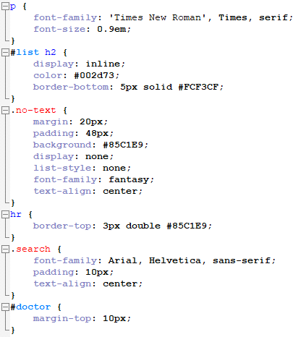

Figure 17: The CSS code used for the search engine optimization and for the profile info for the doctors

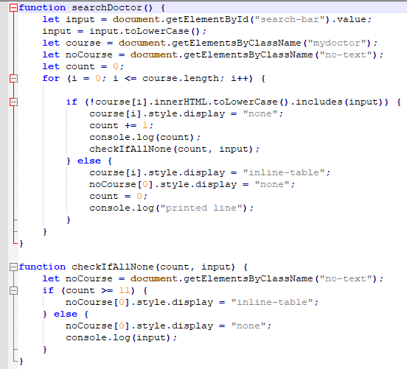

Figure 18: The JavaScript code used for search engine optimization

A client-side script is what JavaScript is called. The interaction between the user's device (e.g., computer, phone, or tablet) and a remote server is at the heart of most Web applications, such as a search engine. The software on the remote server sends data to the client (the user's PC), and the client-side software reads the data and displays a Web page on the screen.

A client-side script is a programming language that runs fully on the client's system and does not require communication with the server to work. If you have a Web page open on your computer and your Internet service provider goes down, you can still interact with the Web pages that are already open in your browser. You will not, however, be able to access any remote data or go to new Web pages.

One of the dynamic website enhancements performed by JavaScript is Autocomplete. Loading new content or data onto the page without reloading the page. Rollover effects and dropdown menus. Animating page elements such as fading, resizing, or relocating. Playing audio and video. Validating input from Web forms. Repairing browser compatibility issues.

# Appointment

The appointment page is where users fill out the appointment form, which includes fields like Name, Symptom, Email, Phone Number, Date, Time, and Confirmation Requested by Email or Phone Call. The screen capture, HTML, and CSS code for the appointment generates information with div class="appointment"> are

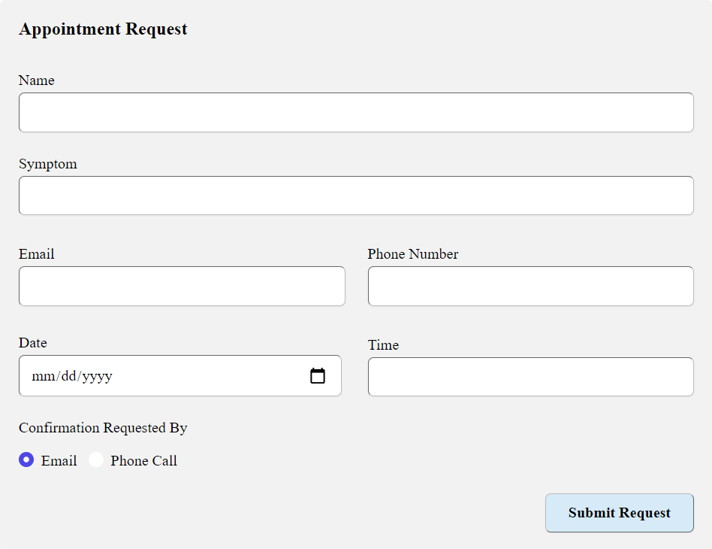

Figure 19: Screen capture of the appointment form

Following the processes below, we were able to set up the form on our website, which included notifying us of new submissions and storing the submission data. Make changes to the HTML code to match our specific needs, such as adding more entry fields.

We may use CSS to customize the form's appearance and design so that it matches the rest of our website. Make use of our ready-made stylesheet. This provides a standard form design (as seen on this page) that should work for most websites.

The following figure 20 has been used to present the HTML code used for the appointment request form in the HTML body document Appointment page.

The CSS codes for it are quite large due to column making, design of the form template, and enabling user’s information input with a notification to users that the form cannot accept submission requests until all the information for the user input has been filled out by the user.

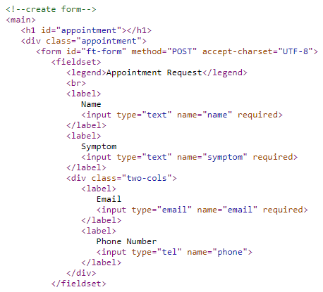

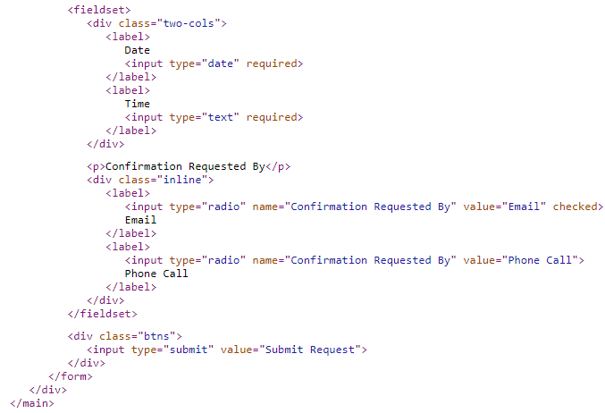

Figure 20: HTML code for appointment development

Visitors to our website can easily submit appointment requests using this sample appointment request form, which is intended for our clients to make appointments with us online.

The following figure 21 shows the screen capture for the CSS development of the appointment form.

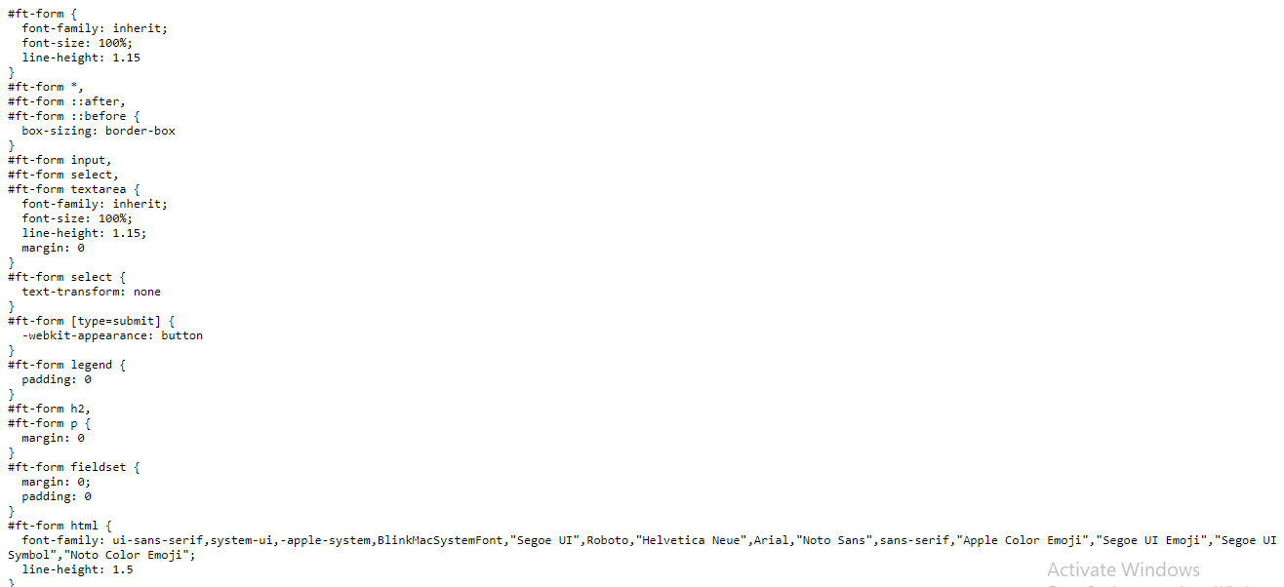

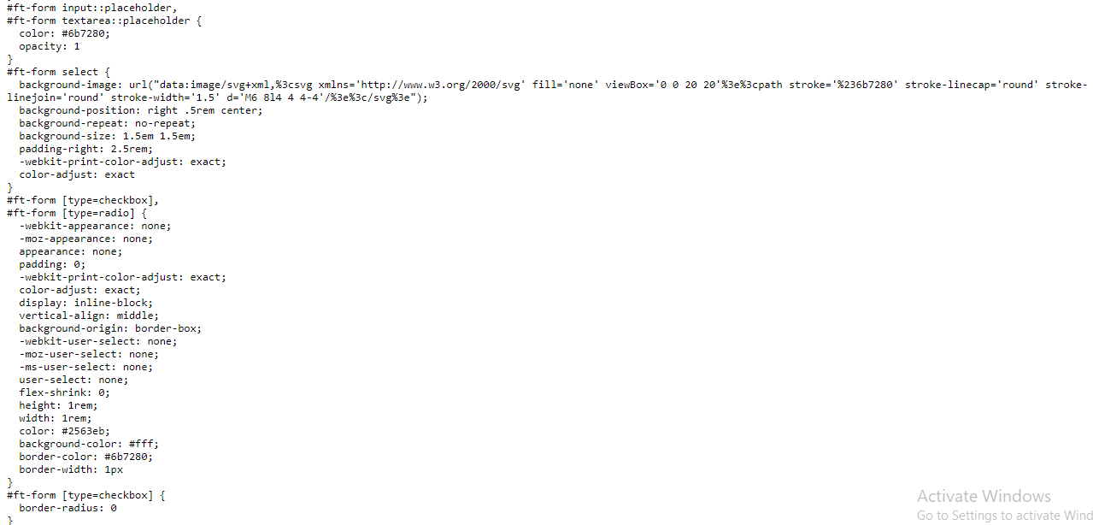

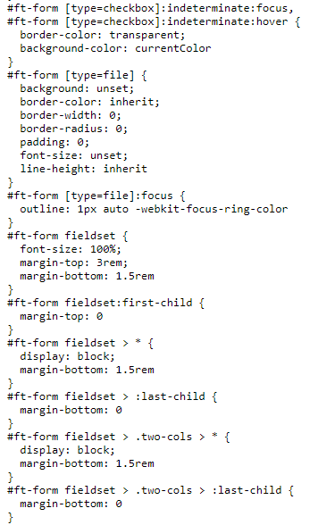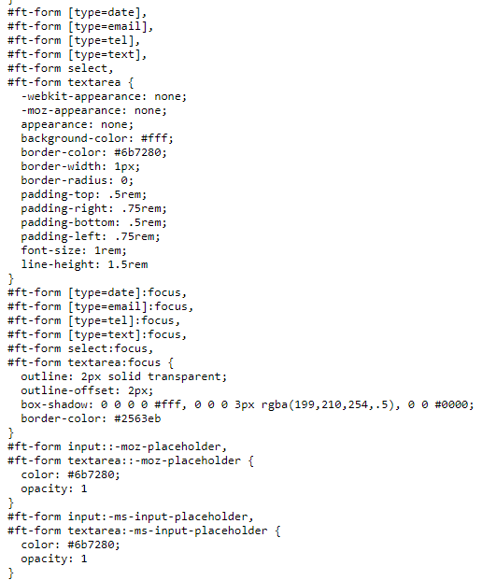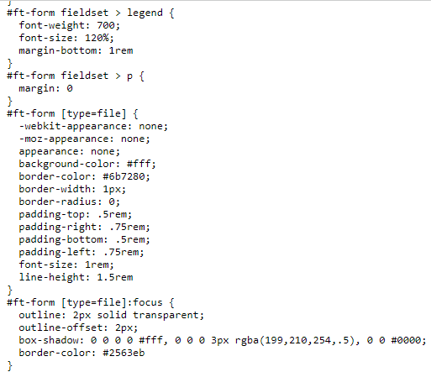

A contact form is a must-have for every online presence. Almost no website can run without this simple method of engaging with site visitors, whether they wish to leave a note or learn more about the homepage's features.



Although a site visitor may send an email, an online form is faster to fill out and so lowers the barrier to contact. It also avoids the need to make the email address public, reducing system abuse such as spam dissemination. CSS is used to customize the form's appearance, allowing it to be matched to the website's design. The site designer will likely be aware of this. CSS layout is mostly based on the box model. Each box taking up space on the page has properties like padding, the space around the content. In the example below, it is the space around the paragraph text. Border, the solid line that is just outside the padding. Margin, the space around the outside of the border.

If a box contains an outer display kind of block, it will act as follows: A new line will be added to the box. To fill the space available in its container, the box will expand in an inline direction. In most circumstances, this means that the box will expand to the same width as its container, taking up all of the available space. The width and height parameters are taken into consideration. Other items will be pushed away from the box as a result of padding, margin, and border.

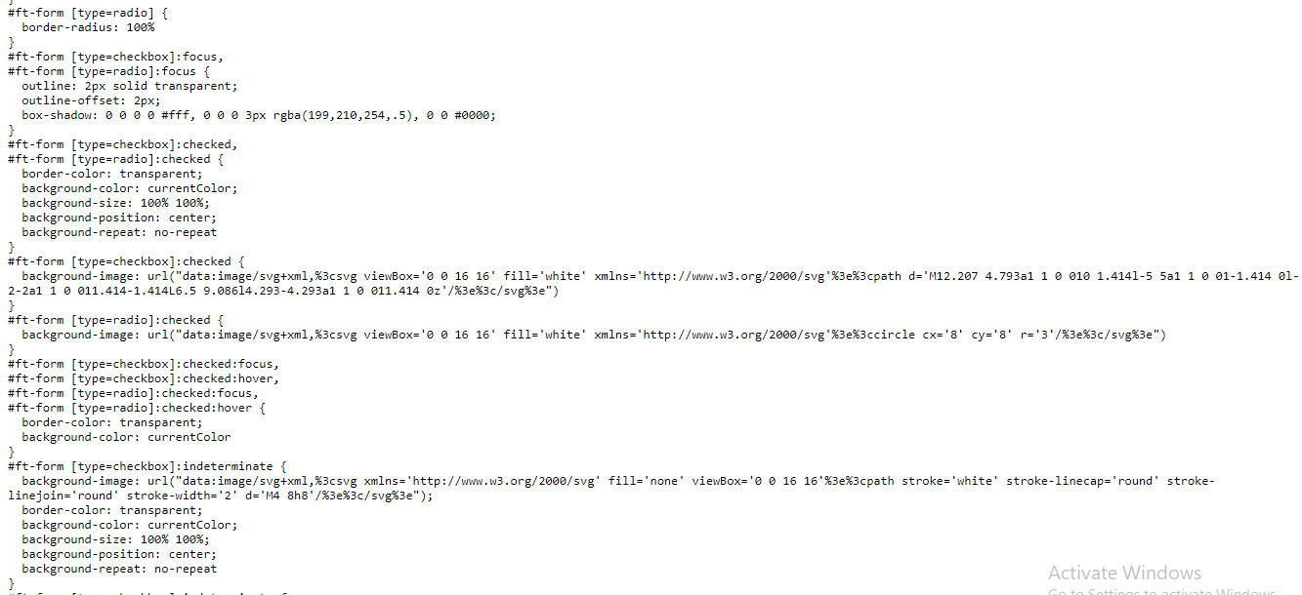

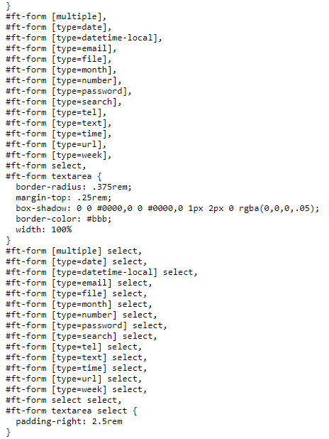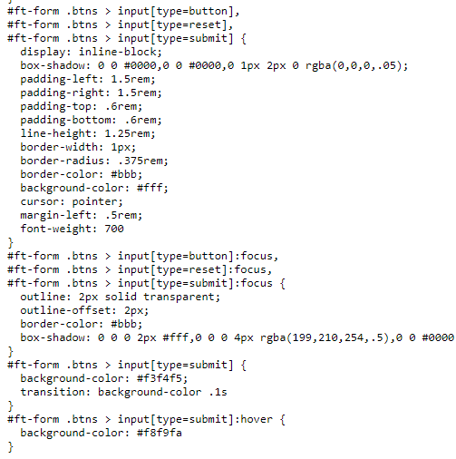

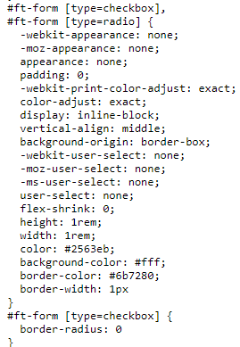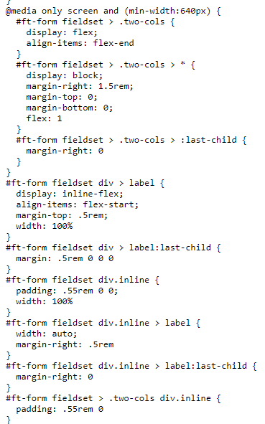

Figure 21: The appointment form on the Appointment page was developed using the CSS code from screen captures above, which were later shown

The HTML5 standard provides additional options for specifying input rules directly in the form's HTML source code:

**Mandatory fields**

Mandatory input fields can be provided with the property needed for this purpose.

<input type="text" name="Your name" required>

**Email inputs**

Type 'email' should be used in fields where email addresses will be entered. Before sending the form, the web browser can verify to see if the input is a formally valid address.

<input type="email" name="Your email address">

**Number input**

Type numbers can be used to create fields for numerical input. It is also possible to limit the permitted value range using the properties min and max.

<input type="number" min="18" max="99" name="Your age">

Block boxes and inline boxes are the two types of boxes in CSS. These properties explain how the box interacts with the page's flow and other boxes. There are two sorts of displays inboxes: inside and outside. We'll start by defining the words "block box" and "inline box." Then we'll go through the differences between inner and outside display types. Block is the default outer display type for several HTML elements, such as h1 and p element. If a box has an inline outer display type, then: The box will not continue to the next line. The width and height attributes will not be used. Vertical padding, margins, and borders will be applied to the box, but other inline boxes will not be moved away from it. Padding, margins, and borders will be applied horizontally, and other inline boxes will be moved away from the box. Some HTML elements, such as <a>, <span>, <em>, and <strong> use inline as their outer display type by default.

# Menu Option

The menu option was created to provide a dropdown option for users to navigate among articles, about, and contact pages. The following code from the following figure 22 presents how the menu option from <div class="menu-bar"> has been created along with the use of <div class="sub-menu">.

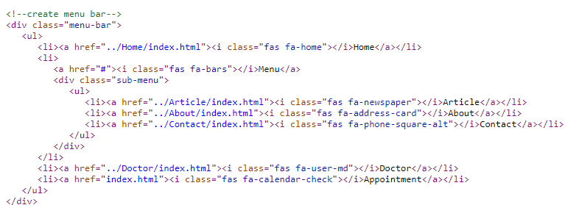

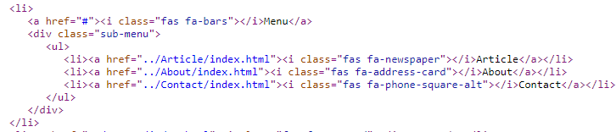

Figure 22 has been used to show the HTML code for the creation of the menu option along with the menu bar

In upcoming sections, we will be elaborating more details about HTML and CSS codes that are primarily for the creation of the article, about, and contact page.

# Contact

The contact page primarily shows the map from google links into an iframe on the web page. The following figure represents the HTML code for the map created along with the CSS.

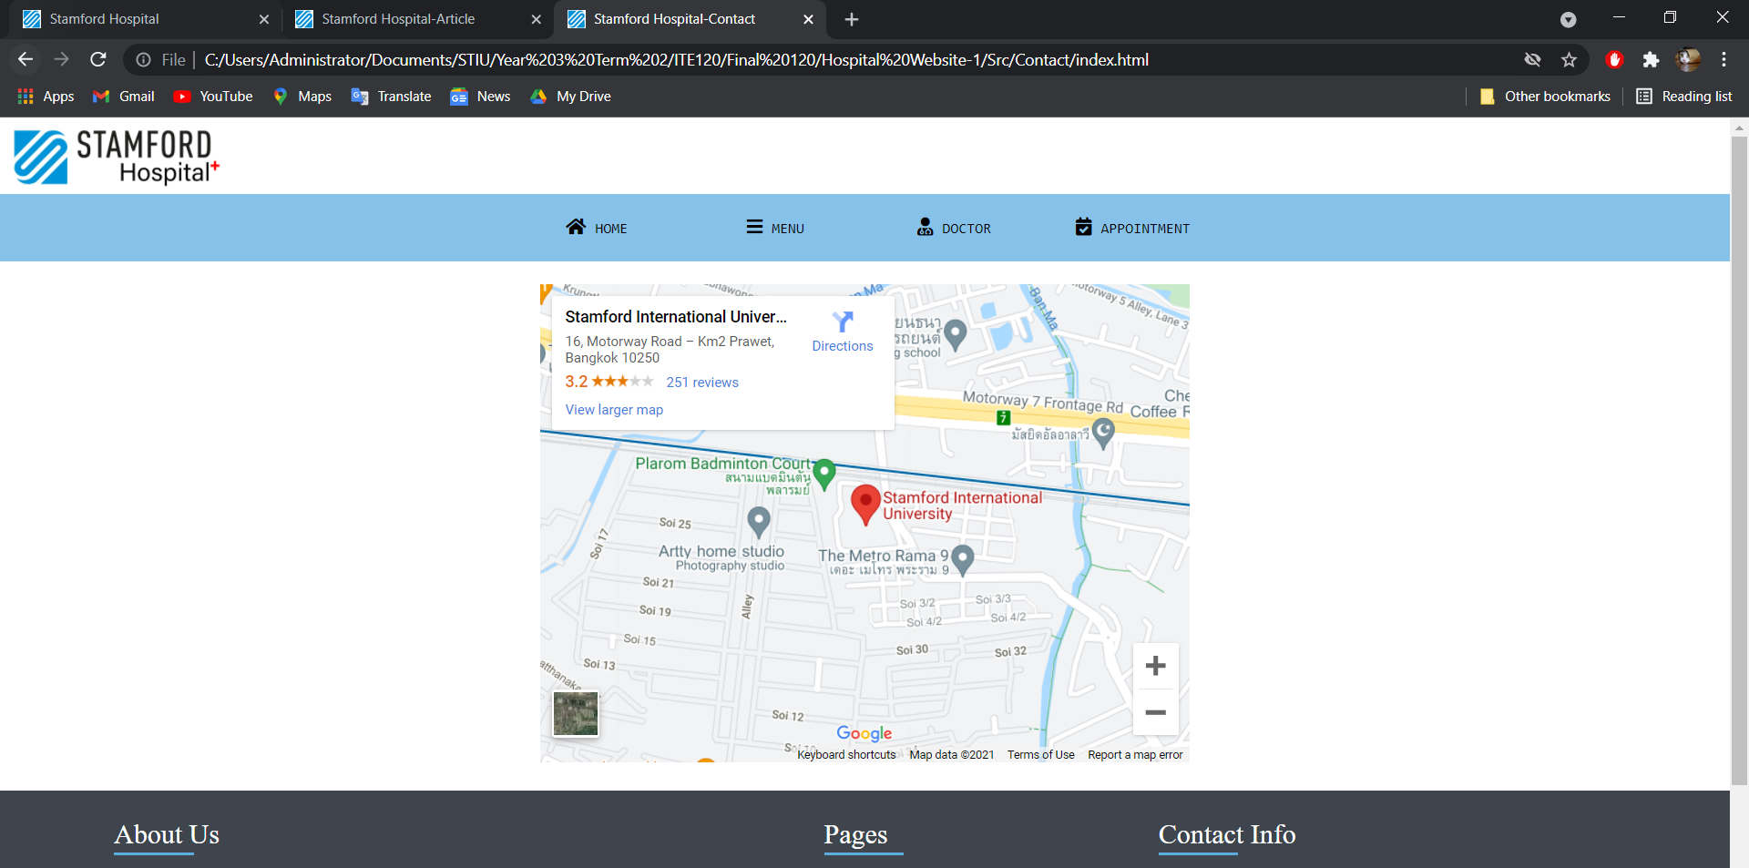

Figure 23: The contact page representing the google map of the location of Stamford Hospital

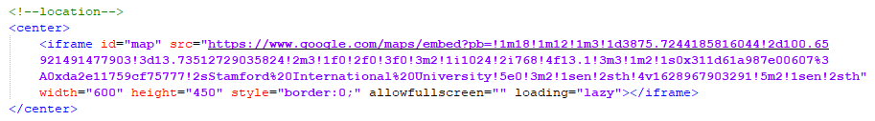Figure 24: HTML code for google map location on Contact page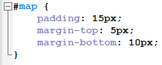

Figure 25: CSS code for google map location on Contact page

# About

The About page has been used to present the background layout of the Hospital image and sections of texts for Info, Vision, and Partners, explaining more about it. The following figures are used to show screen captures of the website:

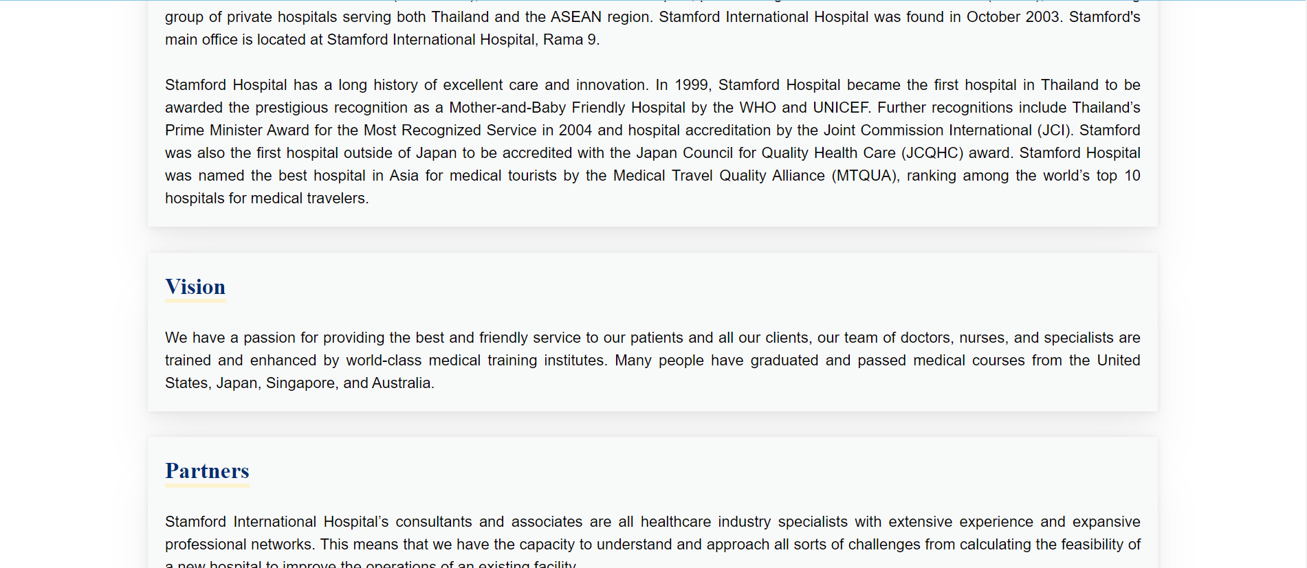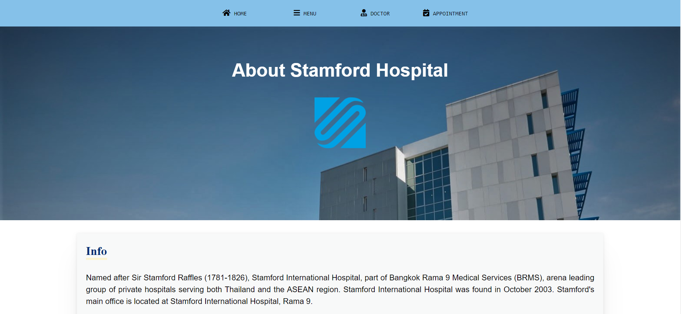

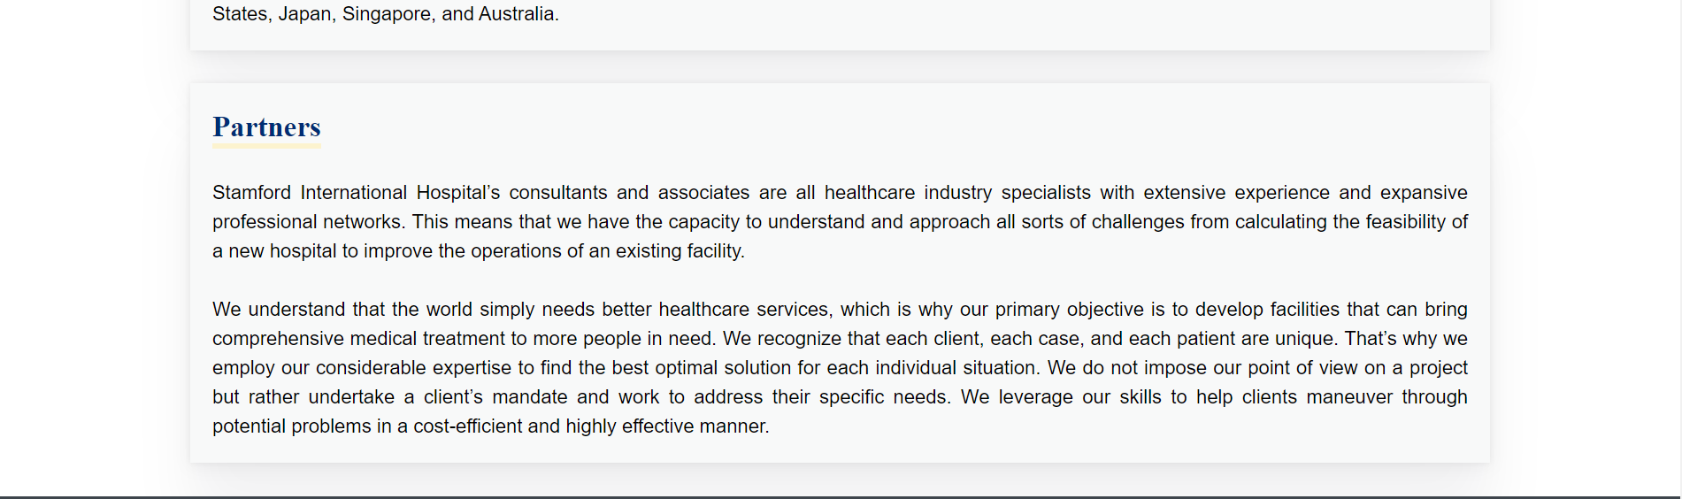

Figure 26: Screen captures of the About page

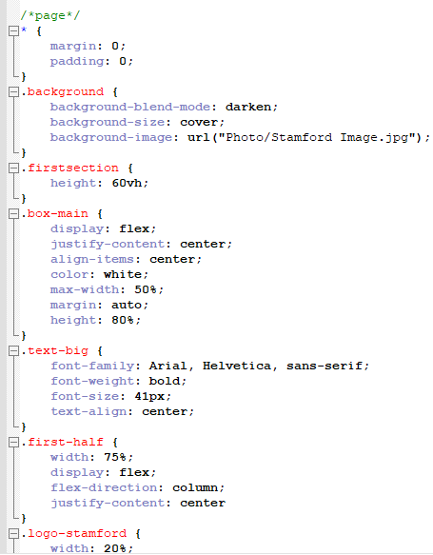

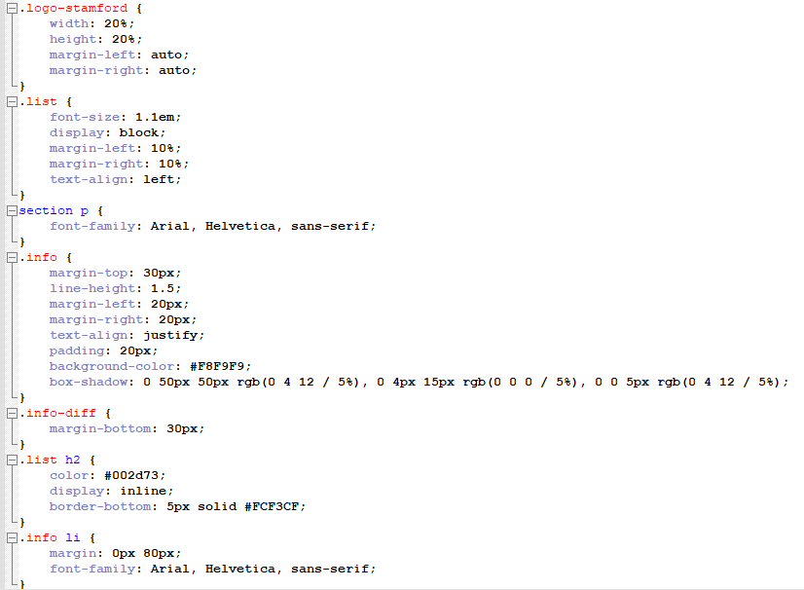

Figure 27: CSS codes used for sections representing relevant information

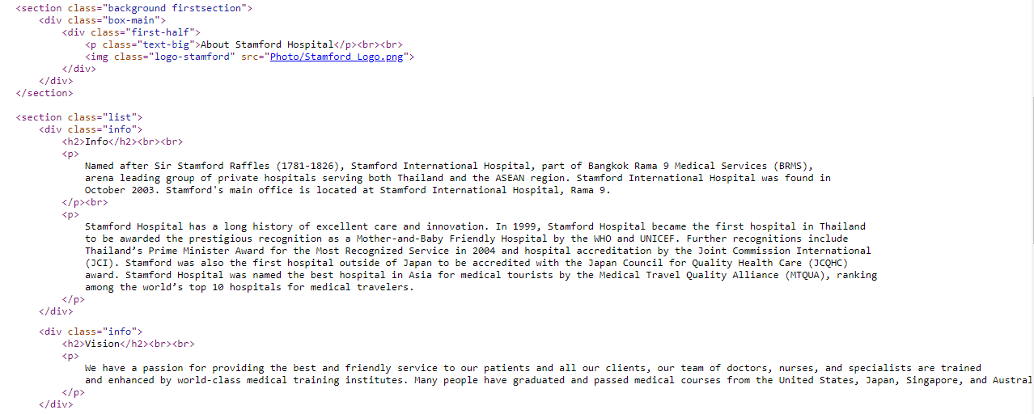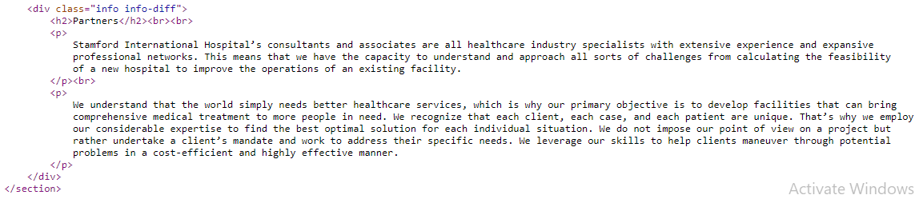

Figure 28: Html code for sections representing relevant information for Info, Vision, and Partners of Stamford Hospital

# Article

The article was utilized to present 12 sections in total. For each news item, each component represents a different style and design. The links in each section can be opened in a new tab to give accurate information from the websites of reputable and well-respected research organizations. The images below show screen captures of the article page as well as the HTML code that was used to create it. Every I-frame class's CSS code is also utilized to change the designs of every area of the Article page.

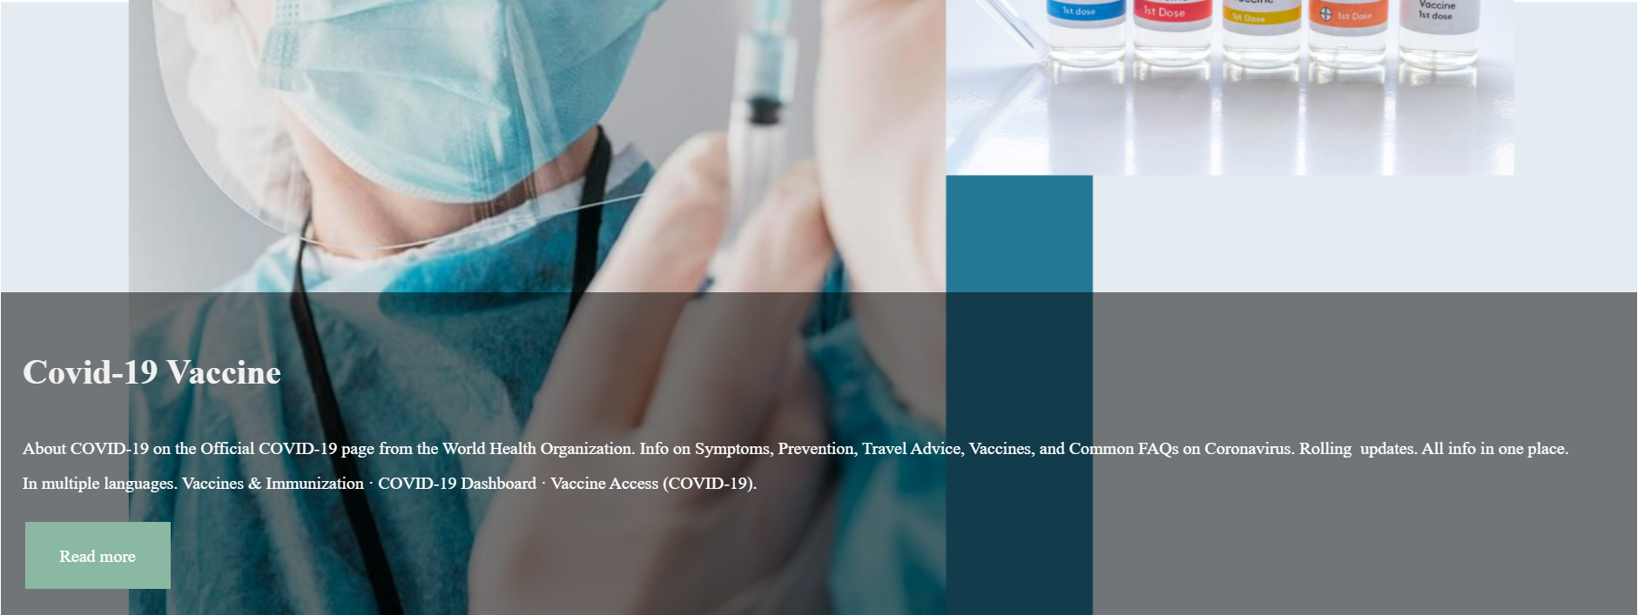

­­­

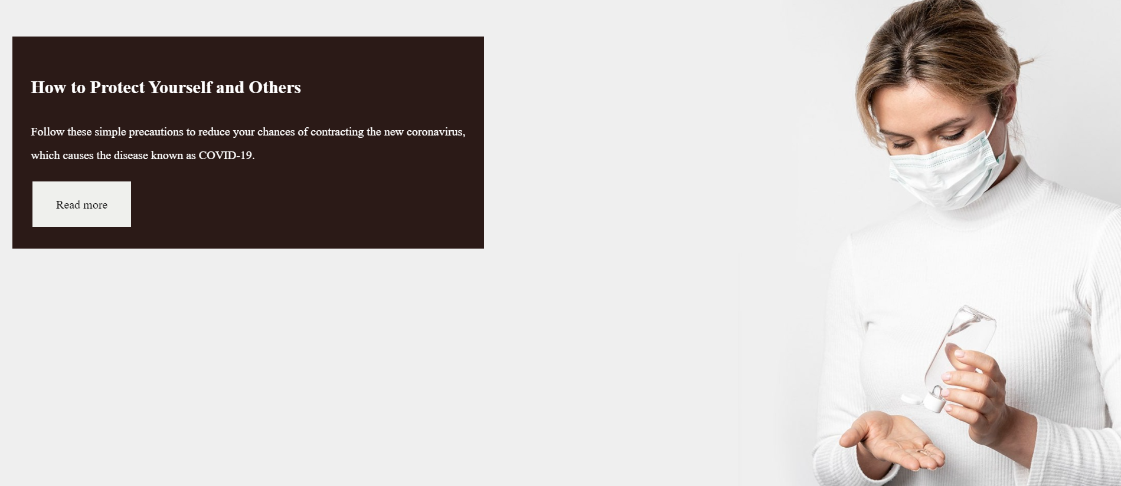

In addition to absolute units, we became familiar with relative units as we began developing web pages with responsive text. Absolute units, such as px, pt, and in, are fixed throughout page presentations and do not alter in size. Relative units, on the other hand, do not have a set value. Instead, they're sized based on the size of a parent element or the viewport (i.e., the visible page area). As the screen size changes, they can scale up and down fluidly with the rest of the page content. The viewport width (vw) unit is proportional to the viewport's width. One vw corresponds to 1% of the current viewport's width. If we use this unit to scale our text, it will grow and shrink accordingly as the browser window is resized, regardless of where it is in our HTML code.



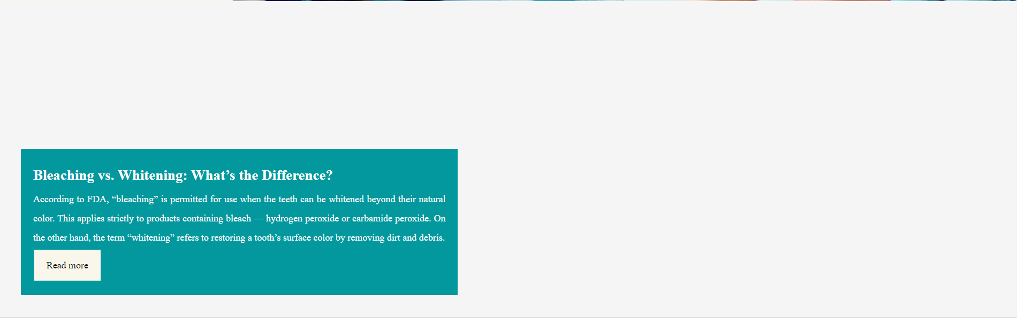



One technique we used to make our website more useable and accessible across multiple screen sizes is by using responsive text. While it's simpler to choose a single font size and apply it to all versions of our website, our visitors may struggle to see our material.

When creating a page for a desktop, for example, we might like to use a font size of 32 pixels for the h2 components so that the headings stand out from the body text. However, if we maintain the same size on a mobile device, the same headlines would appear enormous, potentially distracting readers.

The biggest disadvantage of relying solely on viewport width is that there is no limit to how large or small text can be, which means that text may appear absurdly large or small when switching devices.

Assume we've set the font size to 1.6vw. The text will be a beautiful and readable 16 pixels wide on a browser 1000 pixels wide. On a 300-pixel mobile screen, however, the same text is just approximately five pixels wide, making it unreadable without zooming in.



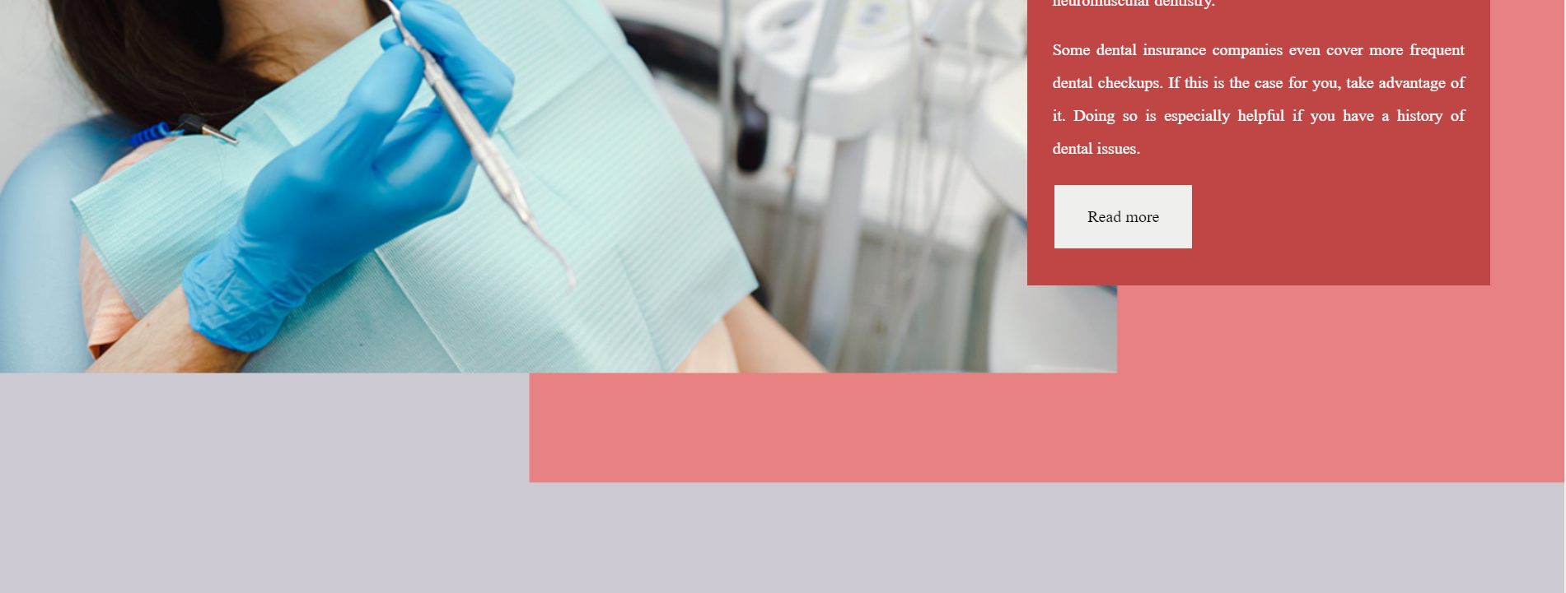­



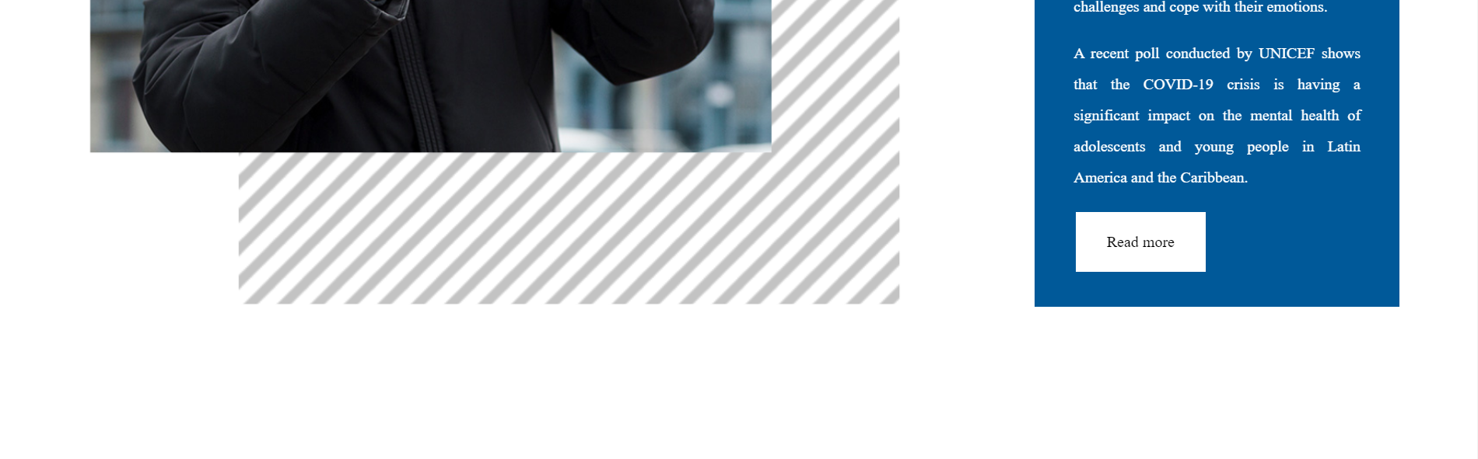­­­­

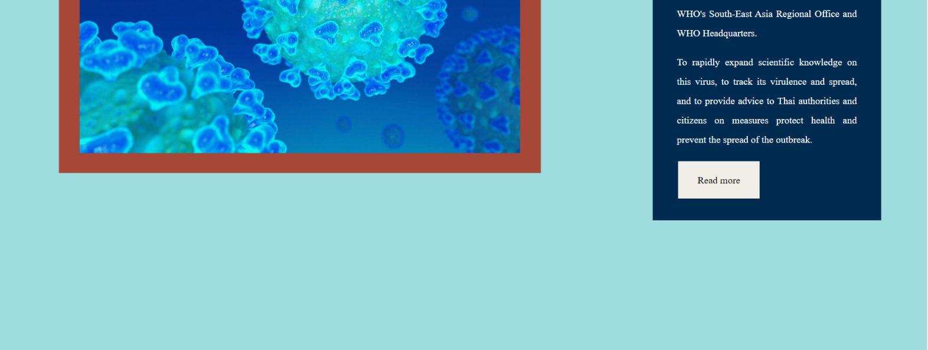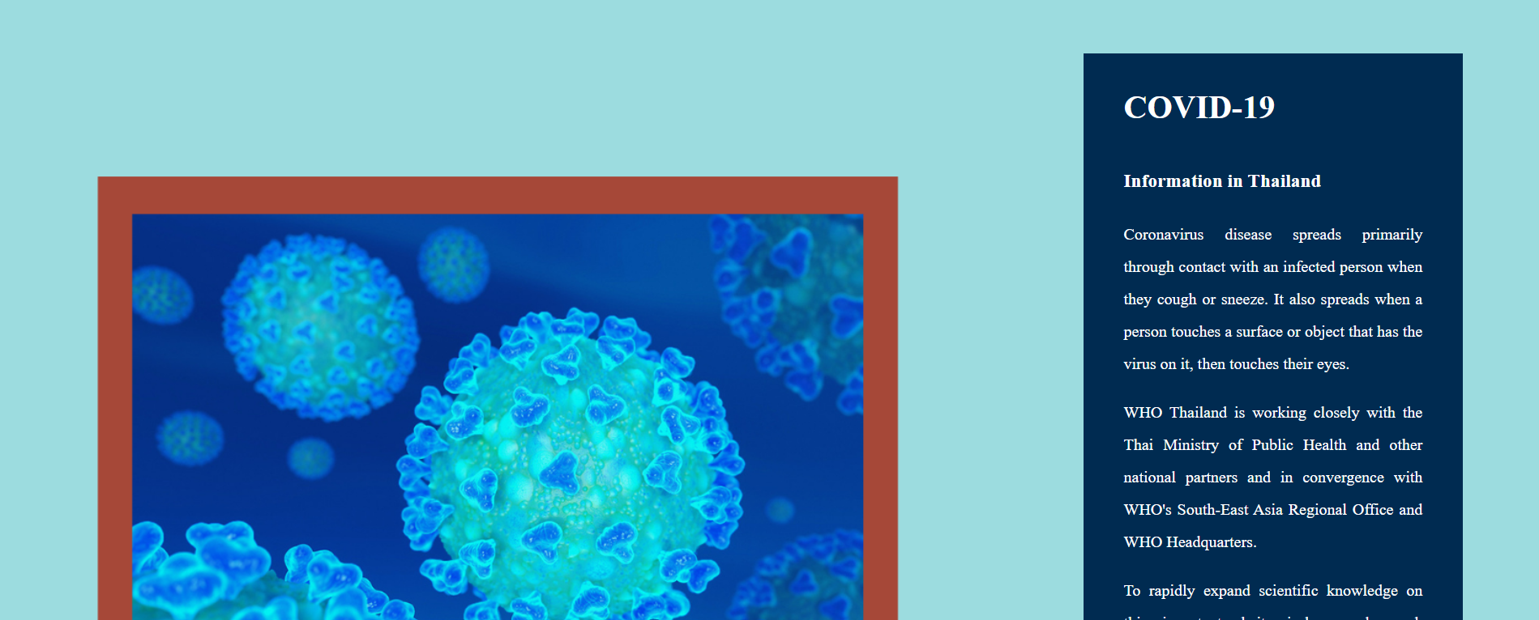

Figure 29: Screen capture of every section of the Article page

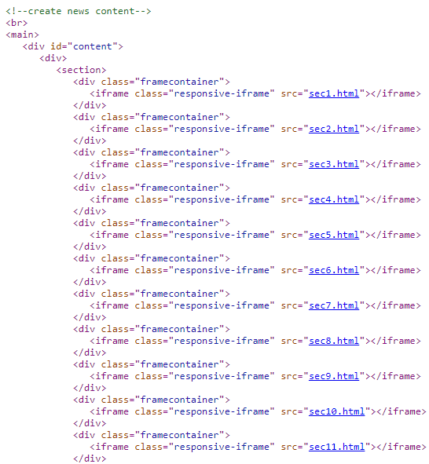

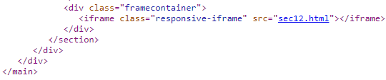

Figure 30: HTML code for importing all sections of news into the Article page

In conclusion, every section was at first created with HTML and CSS code in the form of sec1.html, sec2.html...until sec12.html. The sections were then customized with CSS and designed to fit well on the Article page. They were imported within <div id="content"> for instance using:

<div class="framecontainer"><iframe class="responsive-iframe" src="sec1.html"></iframe></div>.

An iFrame is essentially a frame within a frame. It's an HTML element that allows users to include documents, videos, and interactive media in their pages. On the main page, this displays a secondary webpage. Users can use the iFrame element to embed content from other websites. The term "responsive iframe" is a bit of a misnomer. For example, using 100 percent, 100vw, or 100vh to style an iframe makes it responsive. Because iframes are fluid and cannot alter natively, the conventional approach of producing responsive iframes usually took the form of a tricky JavaScript hack. A better, more modern way generates an aspect ratio box using a simple CSS feature called intrinsic ratios. It's straightforward to make iframes responsive with an aspect ratio box using the intrinsic ratio approach.

We might also make use of the responsive iframe generator. The following are the three steps to making a responsive iframe that keeps its aspect ratio: Make a box with the aspect ratio you choose. Add an iframe container, set the aspect ratio to percent, hide the overflow, and position it relative to the rest of the page. Look for the iframe. Place it in the upper left corner, with the width and height set to 100%. Optimize and style as needed. CSS is used to remove the iframe border, which is then lazy loaded and any unneeded attributes are removed.

# Footer

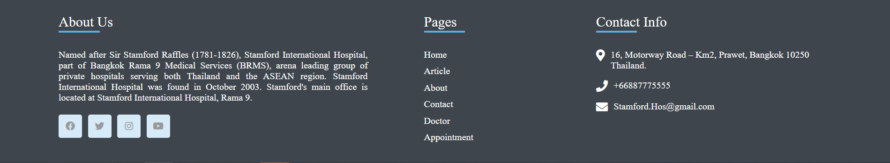The footer includes a short description of the Stamford Hospital in the About Us section of the footer and includes links to all the pages of the website on the Pages section of the website so that when the users reach the end of the page i.e. near the footer, they can click easily to any of the links of the pages they would like to visit next without having to reach back to the top of the website i.e. the menu bar where it also consists of the same pages of the links.

Figure 31: The footer of the website is common on all the pages

The following figures represent the HTML and CSS codes needed to create the footer of the website. For instance, <div class="footer-container"> is used to hold other classes such as <div class="sec f-about-us"> for the short description of the Stamford Hospital in the About Us section of the footer, <div class="sec f-contact-us"> for presenting contact info of Stamford Hospital and <div class="sec pages"> for including links to all the pages of the website.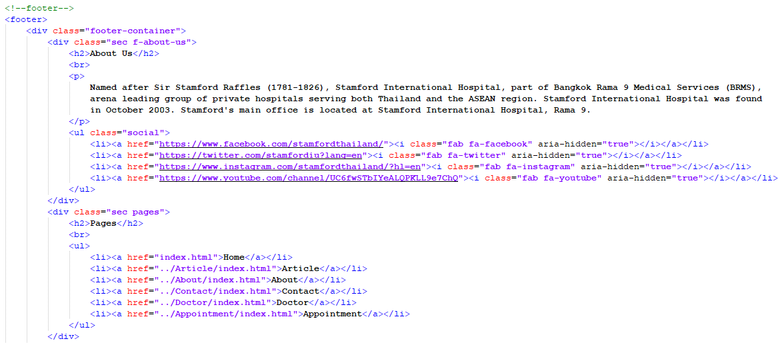

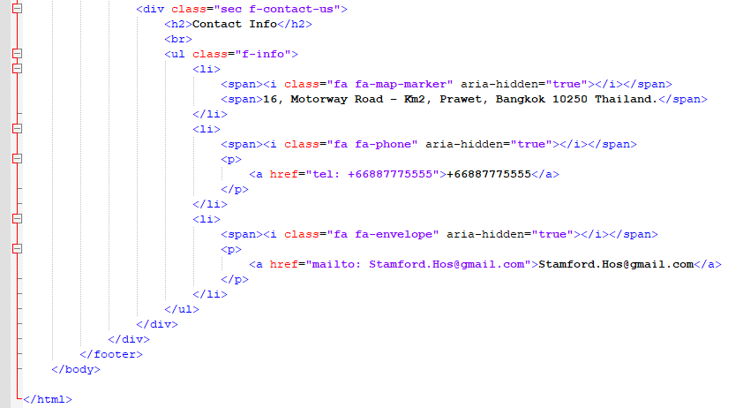

Figure32: HTML code section for the creation of footer

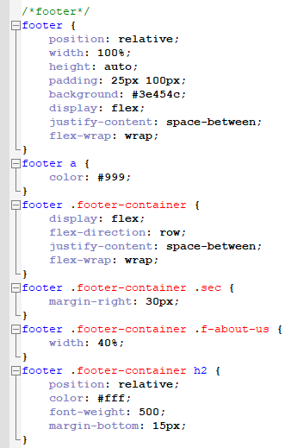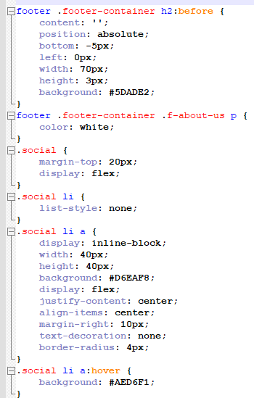

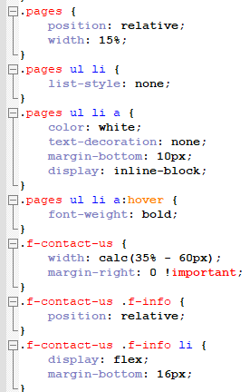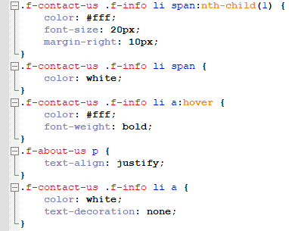

Figure32: HTML code section for the creation of footer

To create a footer for a web page that will stay at the bottom We can move it to the bottom of the page so that the user can see the footer from wherever on the page even if they scroll down the page. To add a footer to the bottom of the page, we may use position: relative. As a result, there is a brief explanation of Stamford Hospital in the About Us section of the footer. The bottom also includes links to all of the website's pages, as well as a section for Contact Us, which gives information on how to contact the hospital in an emergency or to ask any essential questions about the hospital's services.

# Conclusion

The website for Stamford Hospital was built and designed by a hospital or healthcare centre. Because these websites are frequently used by individuals in difficulty, we needed to make sure that ours was user-friendly. For example, on the homepage, visitors should be able to locate specials and bundles on absolute surgery, as well as check COVID-19 and perform a child health check. Users may browse via the menu bar by selecting the main page, then the menu option on the menu bar, which contains an article page, another page about the hospital, and a contact page. The navigation bar also contains a "Doctor" option, which provides details about the clinicians that work at the Stamford Hospital. The website where people may arrange appointments with doctors is the last option on the navigation bar.

There is a brief description of the Stamford Hospital in the About Us section of the footer, as well as links to all of the website's pages in the Pages section, so that users can easily click on any of the links to the pages they want to visit next without having to return to the top of the website. In the Contact Us area, visitors may learn how to contact the hospital in an emergency or to ask any essential questions about the hospital's services. Every company has its own set of web design guidelines. They are, for the most part, fairly similar. However, hospitals must keep in mind that the vast majority of patients who visit their website are looking for immediate assistance or information prior to a visit. As a result, hospitals should strive to adhere to a set of fundamental principles that we previously addressed. On hospital websites, the following characteristics must be present:

It should be simple to operate. From a central place, display the most frequently accessed information and files. Make anyone totally accessible on mobile devices. When considering web design for hospitals, keep these criteria in mind. Without these criteria, our website may be unable to offer prompt and accurate service to patients in emergency situations, causing them to seek treatment from another healthcare practitioner. The HTML, CSS, and JavaScript code for the web pages were written in notepad, and the pages were viewed in web browsers by changing the.txt extension with.html. As a result, the website includes pages that visitors frequently need to view. We'll provide additional information and specifics regarding the material generated for each page, as well as website codes and screenshots. We tried to make the website appealing to the eye while still being responsive, authoritative, user-friendly, and informative.

|-------------------------------------------------The End-------------------------------------------------|